ID&R Parent Survey
Title I, Part C Survey
Parent/ Guardian Information
Name:

Address:

Phone Number:

Name and Age of Children:

Have you or a member of your family moved in the last 36 months to do, or apply for, agriculture or fishing related work, including dairies, nurseries, meat or vegetable processing, feed yards or field work?
Yes_____ No____
Have your children moved with or to join the worker above in the past 36 months?
Yes____ No____
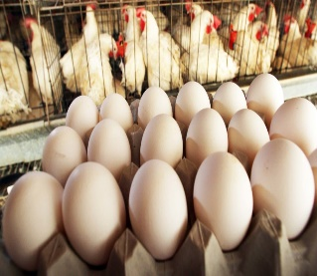
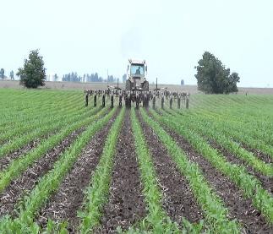
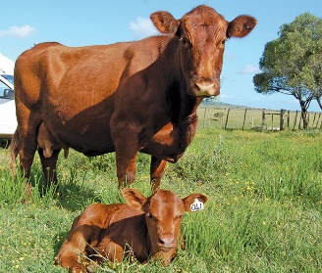

Eggs

Cultivation, Preparation of Soil

Dairy
Feed Cattle, Processing, Packing
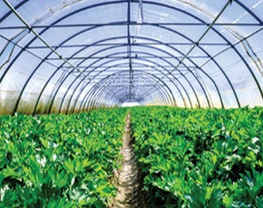
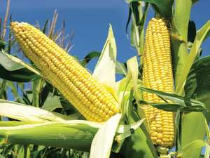
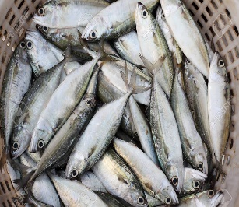
Greenhouse, Nursery, Sod

Trees- Planting, cutting

Harvest (Vegetables & Fruit)

Fishing

